Lab 11 – 24k0880

Q1:
#include <iostream>

using namespace std;

const int TABLE_SIZE = 7;

void solveLinearProbing(int keys[], int numKeys) {
cout << "--- Part 1: Linear Probing ---\n";
int table[TABLE_SIZE];

for (int i = 0; i < TABLE_SIZE; i++) {
table[i] = -1;
}

bool firstCollisionFound = false;

for (int i = 0; i < numKeys; i++) {
int key = keys[i];
int hashIndex = key % TABLE_SIZE;
int currentIndex = hashIndex;

cout << "Inserting Key " << key << ": Hash(" << key << ") = " << hashIndex;

if (table[currentIndex] != -1) {
cout << " -> Collision at index " << currentIndex;

if (!firstCollisionFound) {
cout << " [FIRST COLLISION DETECTED]";
firstCollisionFound = true;
}

int probes = 0;
while (table[currentIndex] != -1 && probes < TABLE_SIZE) {
currentIndex = (currentIndex + 1) % TABLE_SIZE;
probes++;
}
cout << " -> Probed to index " << currentIndex;
}

table[currentIndex] = key;
cout << " -> Placed at index " << currentIndex << endl;
}

cout << "\nFinal Linear Probing Table:\n";
for (int i = 0; i < TABLE_SIZE; i++) {
cout << "Index " << i << ": ";
if (table[i] == -1) cout << "Empty";
else cout << table[i];
cout << endl;
}
cout << endl;
}

struct Node {
int data;
Node* next;
};

void solveSeparateChaining(int keys[], int numKeys) {
cout << "--- Part 2: Separate Chaining ---\n";

Node* table[TABLE_SIZE];

for (int i = 0; i < TABLE_SIZE; i++) {
table[i] = nullptr;
}

for (int i = 0; i < numKeys; i++) {
int key = keys[i];
int index = key % TABLE_SIZE;

Node* newNode = new Node;
newNode->data = key;
newNode->next = nullptr;

if (table[index] == nullptr) {
table[index] = newNode;
} else {
Node* temp = table[index];
while (temp->next != nullptr) {
temp = temp->next;
}
temp->next = newNode;
}
}

cout << "Final Separate Chaining Table Structure:\n";
for (int i = 0; i < TABLE_SIZE; i++) {
cout << "Index " << i << ": ";
Node* temp = table[i];
if (temp == nullptr) {
cout << "NULL";
} else {
while (temp != nullptr) {
cout << temp->data;
if (temp->next != nullptr) cout << " -> ";
temp = temp->next;
}
}
cout << endl;
}

cout << "\nAnalysis for Key 55:\n";
int idx55 = 55 % TABLE_SIZE;
cout << "Calculated Hash Index: " << idx55 << endl;
cout << "Final Placement: Index " << idx55 << ", linked after key 76." << endl;
}

int main() {
int keys[] = {76, 93, 40, 47, 10, 55};
int numKeys = 6;

solveLinearProbing(keys, numKeys);

cout << "------------------------------------------------\n";

solveSeparateChaining(keys, numKeys);

return 0;
}

Output:
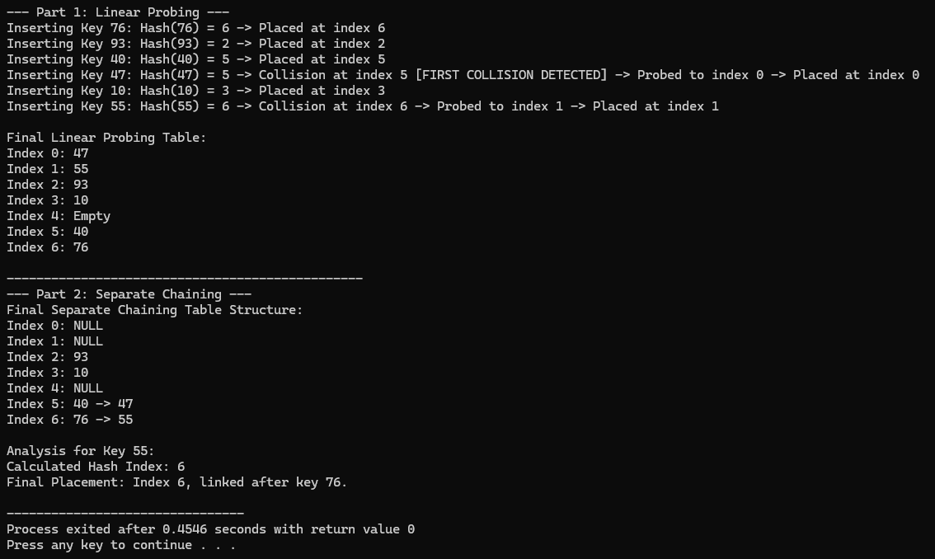

Q2:
#include <iostream>

using namespace std;

bool isPrime(int n) {
if (n <= 1) return false;
for (int i = 2; i * i <= n; i++) {
if (n % i == 0) return false;
}
return true;
}

int nextPrime(int n) {
while (!isPrime(n)) {
n++;
}
return n;
}

struct HashTable {
int* table;
int capacity;
int count;

HashTable(int size) {
capacity = size;
count = 0;
table = new int[capacity];
for (int i = 0; i < capacity; i++) {
table[i] = -1;
}
}

double getLoadFactor() {
return (double)count / capacity;
}

void rehash() {
int oldCapacity = capacity;
int* oldTable = table;

int newCapacity = nextPrime(oldCapacity * 2);

cout << "\n[Rehashing Triggered!]" << endl;
cout << "Old Size: " << oldCapacity << " -> New Size: " << newCapacity << endl;

table = new int[newCapacity];
capacity = newCapacity;
count = 0;

for (int i = 0; i < capacity; i++) {
table[i] = -1;
}

cout << "Migrating elements..." << endl;
for (int i = 0; i < oldCapacity; i++) {
if (oldTable[i] != -1) {
insertWithoutResize(oldTable[i]);
}
}

delete[] oldTable;
cout << "Rehashing Complete.\n" << endl;
}

void insertWithoutResize(int key) {
int index = key % capacity;

while (table[index] != -1) {
index = (index + 1) % capacity;
}

table[index] = key;
count++;
}

void insert(int key) {
if (getLoadFactor() >= 0.75) {
rehash();
}

int index = key % capacity;

while (table[index] != -1) {
index = (index + 1) % capacity;
}

table[index] = key;
count++;

cout << "Inserted key " << key << ". Current Load Factor: " << getLoadFactor() << endl;
}

void display() {
cout << "Table State (Size " << capacity << "): ";
for (int i = 0; i < capacity; i++) {
if (table[i] != -1) cout << "[" << table[i] << "] ";
else cout << "[_] ";
}
cout << endl;
}
};

int main() {
cout << "--- Initializing Table with size 4 ---" << endl;
HashTable ht(4);

ht.insert(10);
ht.insert(20);
ht.insert(30);

ht.display();

ht.insert(40);

ht.display();

return 0;
}

Output:
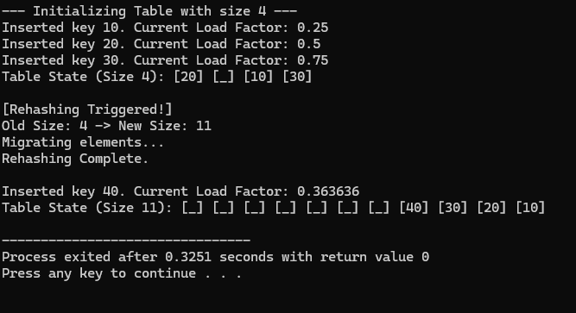
Q3:
#include <iostream>
#include <string>

using namespace std;

void solveBruteForce(string T, string P) {
cout << "--- Part 1: Brute Force Search ---\n";
int n = T.length();
int m = P.length();

for (int i = 0; i <= 1; i++) {
cout << "\nWindow " << (i + 1) << " (Pattern at Index " << i << "):\n";
cout << "Text: " << T << endl;
cout << "Pattern: ";
for(int s=0; s<i; s++) cout << " ";
cout << P << endl;

for (int j = 0; j < m; j++) {
cout << " Comparing T[" << (i + j) << "] ('" << T[i + j] << "') vs P[" << j << "] ('" << P[j] << "')... ";
if (T[i + j] != P[j]) {
cout << "Mismatch found! Shift pattern.\n";
break;
} else {
cout << "Match.\n";
}
}
}
}

void solveBoyerMooreCalc(string P, char badChar, int mismatchIndexInP) {
cout << "\n--- Part 2: Boyer-Moore Bad Character Heuristic ---\n";

int m = P.length();
int badCharIndexInP = -1;

for (int i = mismatchIndexInP - 1; i >= 0; i--) {
if (P[i] == badChar) {
badCharIndexInP = i;
break;
}
}

cout << "Pattern: " << P << endl;
cout << "Bad Character from Text: '" << badChar << "'" << endl;
cout << "Mismatch occurred at Pattern Index: " << mismatchIndexInP << endl;

int shift;
if (badCharIndexInP == -1) {
cout << "'" << badChar << "' does NOT exist in Pattern.\n";
shift = mismatchIndexInP - (-1);
} else {
cout << "Rightmost occurrence of '" << badChar << "' in Pattern is at index " << badCharIndexInP << endl;
shift = mismatchIndexInP - badCharIndexInP;
}

cout << "Calculated Shift: " << shift << " positions." << endl;
}

int main() {
string T = "GCAATGCCCTATGTGACC";
string P = "TATGT";

solveBruteForce(T, P);

solveBoyerMooreCalc(P, 'C', 4);

return 0;
}
Output:
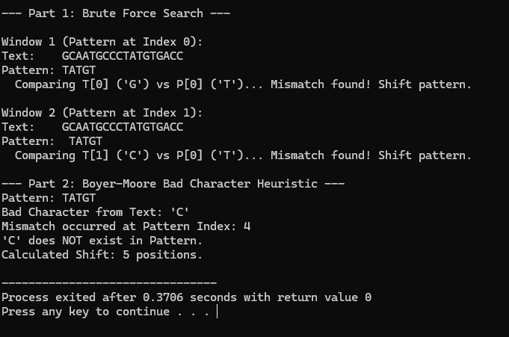

Q4:
#include <iostream>
#include <string>

using namespace std;

void computeLPSArray(string pat, int* lps) {
int len = 0;
int i = 1;
int M = pat.length();

lps[0] = 0;

while (i < M) {
if (pat[i] == pat[len]) {
len++;
lps[i] = len;
i++;
} else {
if (len != 0) {
len = lps[len - 1];
} else {
lps[i] = 0;
i++;
}
}
}
}

void KMPSearch(string pat, string txt) {
int M = pat.length();
int N = txt.length();

int* lps = new int[M];

computeLPSArray(pat, lps);

cout << "--- LPS Array Construction ---" << endl;
cout << "Pattern: " << pat << endl;
cout << "LPS: ";
for (int k = 0; k < M; k++) {
cout << lps[k] << " ";
}
cout << endl << endl;

cout << "--- KMP Search Trace ---" << endl;
int i = 0;
int j = 0;

while (i < N) {
if (pat[j] == txt[i]) {
j++;
i++;
}

if (j == M) {
cout << "Found pattern at index " << (i - j) << endl;
j = lps[j - 1];
}
else if (i < N && pat[j] != txt[i]) {
cout << "Mismatch at P[" << j << "] vs T[" << i << "]. ";
if (j != 0) {
cout << "Using LPS[" << (j - 1) << "] = " << lps[j - 1];
j = lps[j - 1];
cout << ". New Pattern Index: " << j << endl;
} else {
cout << "j is 0. Increment Text Index." << endl;
i = i + 1;
}
}
}

delete[] lps;
}

int main() {
string pattern = "ABABA";
string text = "ABABBABABA";

KMPSearch(pattern, text);

return 0;
}
Ouput:
